ST PHILOMENA COLLEGE(AUTONOMOUS)
PUTTUR
DEPT OF COMPUTER SCIENCE

TITLE OF THE PROJECT
“AI Crop Disease Detection and Treatment System”

Submitted By:
Shruthy. R.S A.V. Ancilla Mary
(Reg. no: U05PH23C0198) (Reg. no: U05PH23C0201)
Jeevitha
(Reg no: U05PH23C0184)

Submitted To:

Internal Guide Head of Department
Dr. Vinayachandra Dr. Vinayachandra
Dept. Computer Science Dept. Computer Science

SYSTEM DESIGN DESCRIPTION
- Introduction
The AI Crop Disease Detection and Treatment Recommendation System helps farmers detect crop diseases by analyzing leaf images using artificial intelligence. The system identifies the disease and provides suitable treatment recommendations.
The Software Design Document (SDD) describes the system architecture, modules, and design of the system. It serves as a blueprint for development and ensures that the system design follows the specified requirements.

1.1 Background
Agriculture is the backbone of India’s economy, but crop diseases cause significant yield loss and financial hardship for farmers. Traditional manual inspection is slow, costly, and often inaccessible in rural areas. This system leverages AI and Machine Learning to automatically detect crop diseases from leaf images and provide instant treatment recommendations, bridging the gap between farmers and agricultural expertise.

1.2 References
- Mohanty et al. (2016). Plant Disease Detection Using Deep Learning
- Kaggle PlantVillage Dataset
- Maria Diaz (2023). What is Artificial Intelligence – ZDNET

- Functional Decomposition – System Description
The AI Crop Disease Detection and Treatment System allows users to upload images of crop leaves. The system analyzes the image using AI to detect diseases. If a disease is identified, the system provides the disease name and suitable treatment recommendations to the user.

2.1 System Software Architecture
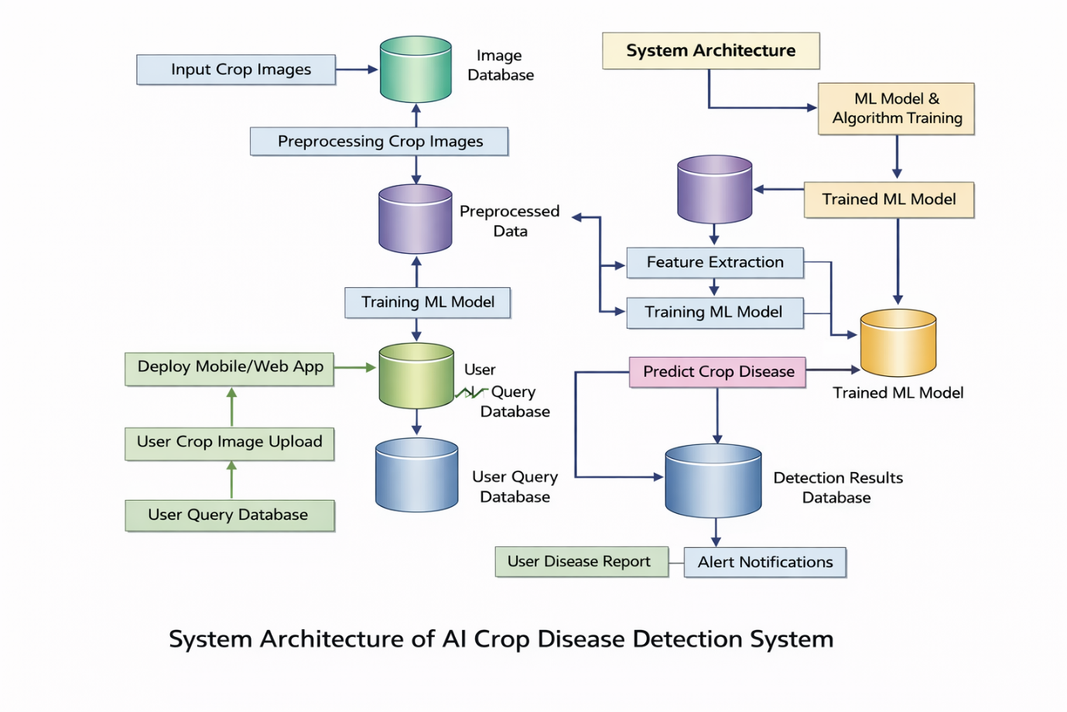
The AI Crop Disease Detection and Treatment Recommendation System allows users to upload images of crop leaves through a user interface. The uploaded image is processed and analyzed using a trained AI/Deep Learning model to detect diseases in crops such as tomato, spinach, brinjal, ladyfinger, and arecanut. The system then classifies the disease and retrieves appropriate treatment recommendations from the database. Finally, the results, including the disease name and suggested treatment, are displayed to the user.

2.2 System Technical Architecture
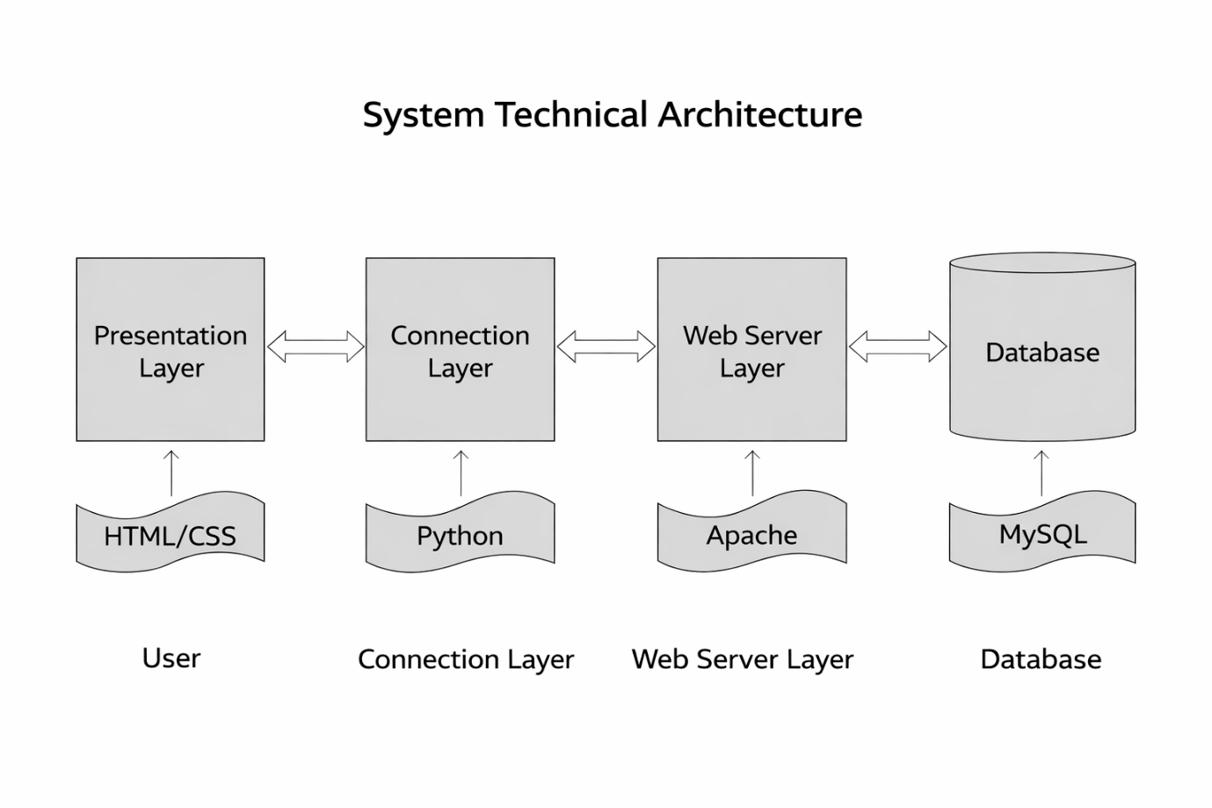

Presentation Layer:
- Technologies: HTML, CSS, JavaScript
- Role: Farmer/Admin interface for uploading images and viewing results
Connection Layer:
- Technology: Python (Flask)
- Role: Handles user requests, routes to AI model, manages logic

Web Server Layer:
- Technology: Apache/Nginx
- Role: Manages HTTP requests, security, and deployment
Database Layer:
- Technology: MySQL / SQLite
- Role: Stores crop, disease, treatment, and prediction data

2.3 System Hardware Architecture
The system does not require specialized hardware components and can operate on standard computer systems.
Minimum Hardware Requirement
- Development: Windows 7+, 8 GB RAM, 250 GB HDD, 2.4 GHz Processor
- Implementation: Web server + Database server, firewall protection, user workstations.
  - External Interfaces
A.Name of Application:
AI Crop Disease Detection and Treatment Recommendation System
B. Owner of Application (if external):
Datasets and AI libraries are maintained by their respective developers
C. Details of Interface:
The system interacts with image input from the user and processes it through the AI model to detect crop diseases.
D. Type of Interface:
User interface (web interface) and software interface with machine learning libraries.
E. Operational Implications & Security:
Uploaded images are processed securely, and user data is protected to prevent unauthorized access.
F. Data Transfer Requirements:
Image files of crop leaves are uploaded to the system, processed by the AI model, and results are returned to the user.
G. Data Formats:
Input: Image files (JPG/PNG).
Output: Disease name and treatment recommendation in text format.
H. Interface Procedures:
User uploads an image → system processes the image → AI model predicts disease → results are displayed.
I. Interface Equipment:
Computer or mobile device with internet access.
J. Data Conversion Requirements:
Uploaded images are converted into a format suitable for the AI model for processing.

3. Description of Programs – Subsystem Specification
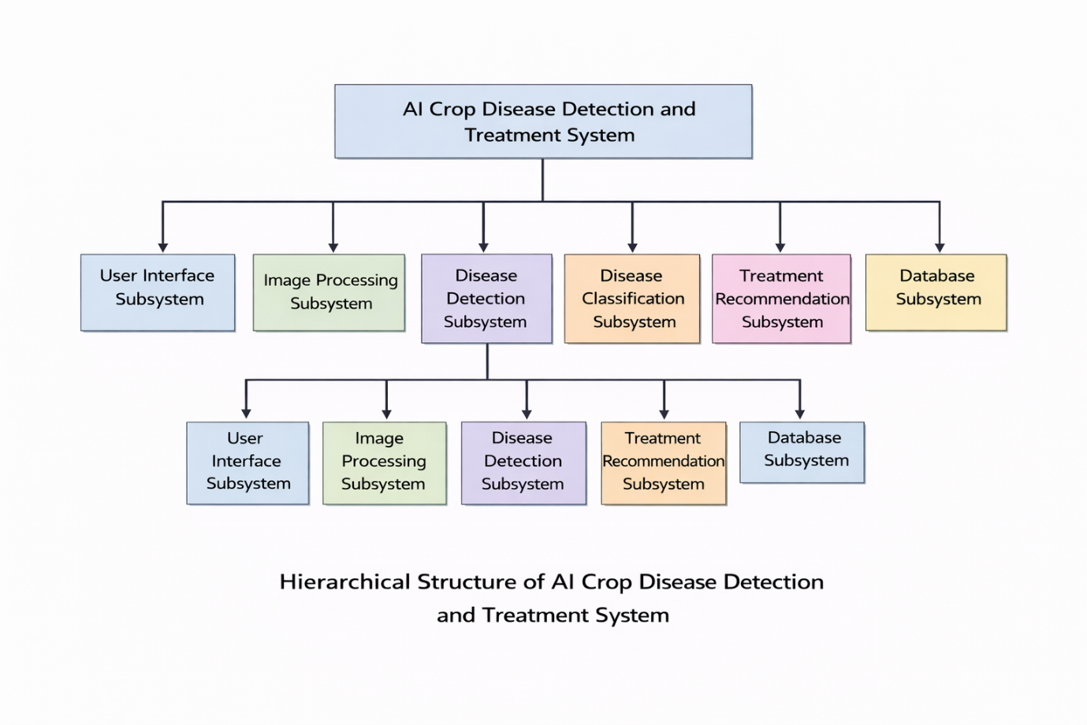3.1 Context Flow Diagram (CFD)
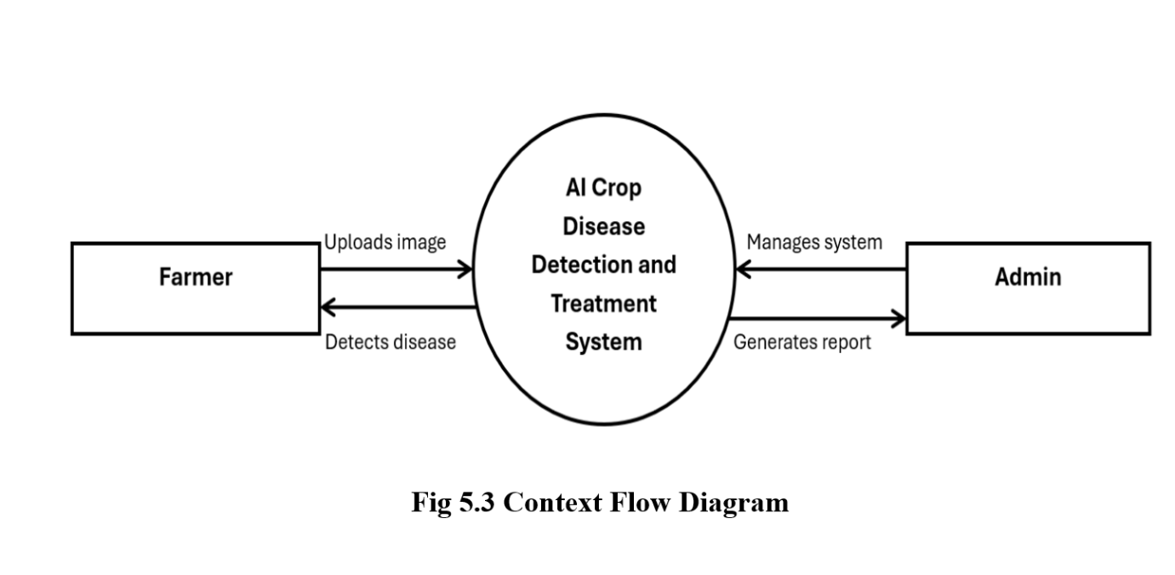

3.2 Top Level DFD
- Farmer uploads image → Image Processing → AI Model → Disease Database → Recommendation → Farmer
- Admin updates disease/treatment → Database → System
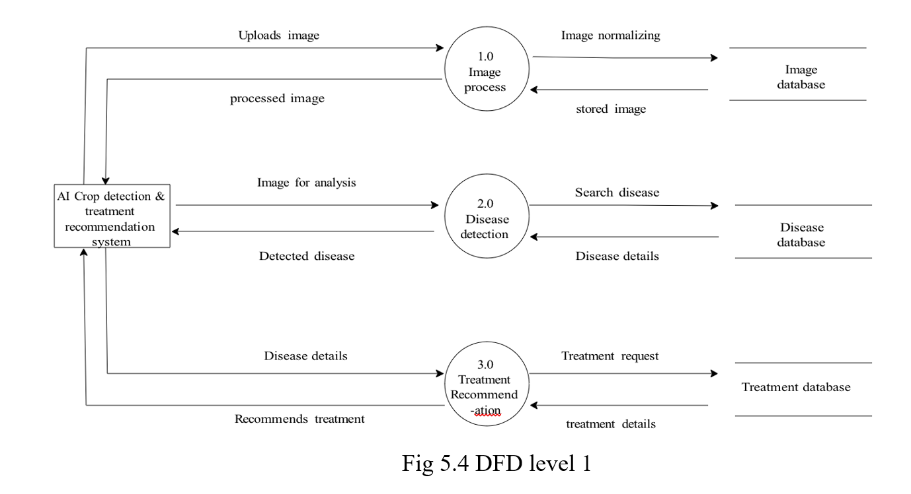

3.3 Description of Components
- Farmer Module
  - Input: Leaf image
  - Process: Upload, disease detection, recommendation retrieval
  - Output: Disease name, treatment suggestion
- Admin Module
  - Input: Disease/treatment data
  - Process: Add/update records
  - Output: Updated database

- AI Disease Detection Module
  - Input: Preprocessed image
  - Process: CNN classification
  - Output: Disease prediction + accuracy score
- Recommendation Module
  - Input: Disease ID
  - Process: Fetch treatment data
  - Output: Fertilizer/pesticide suggestion

